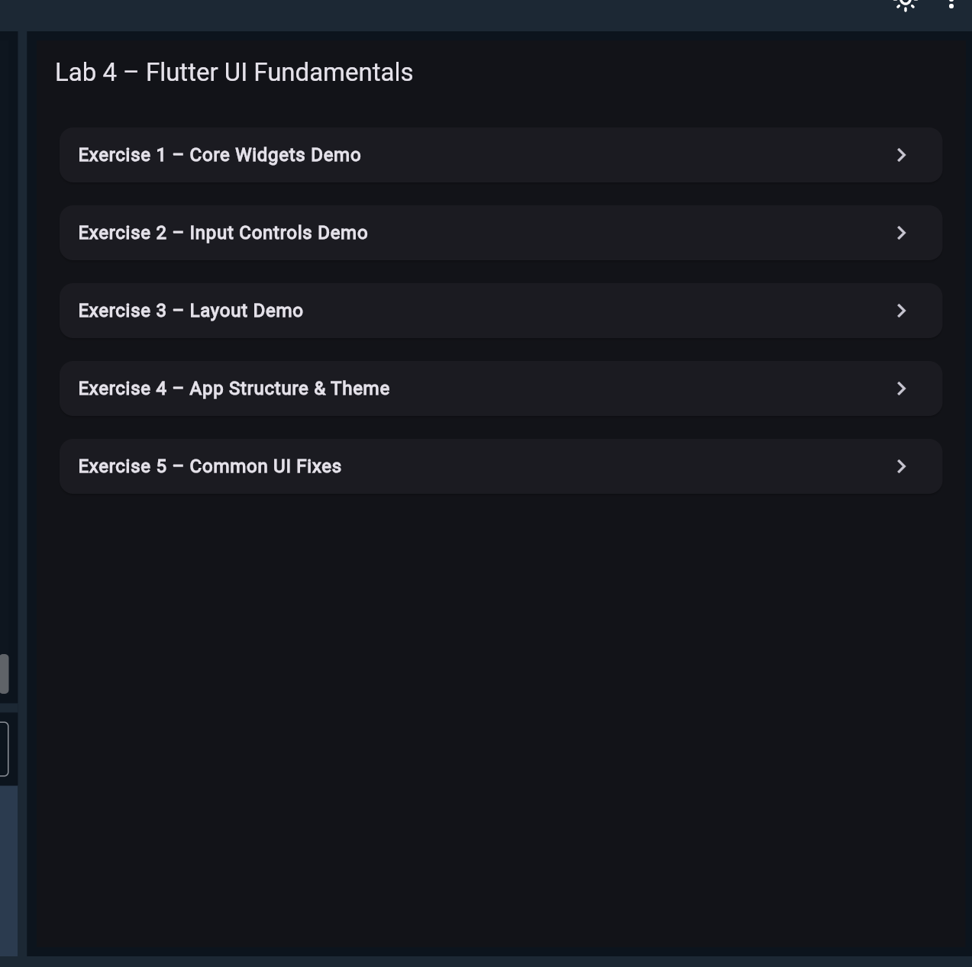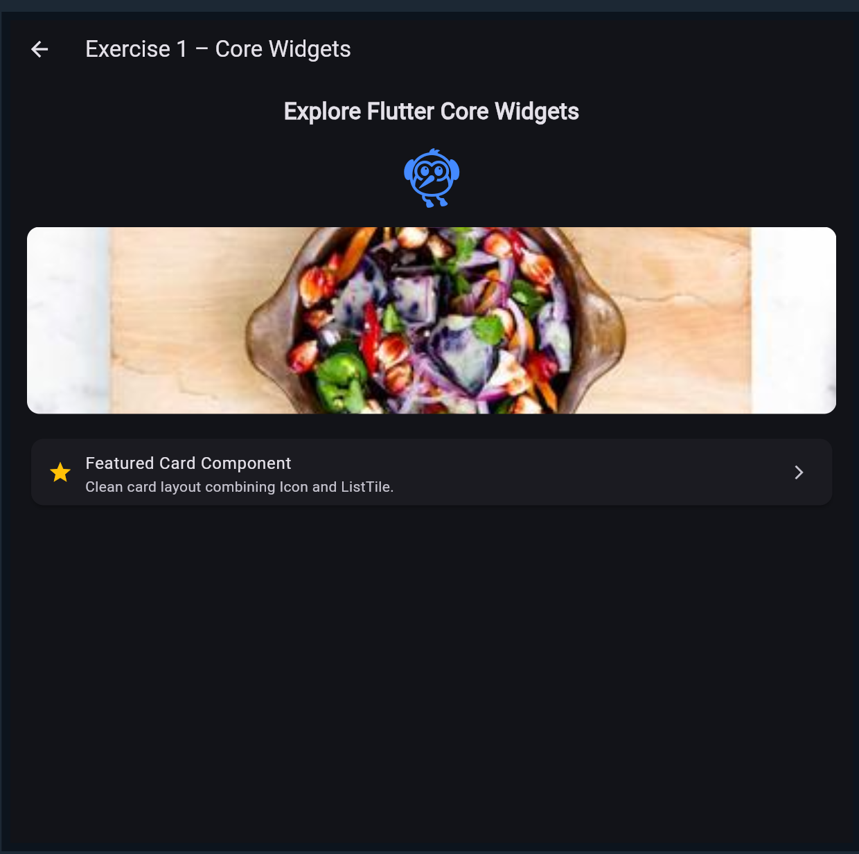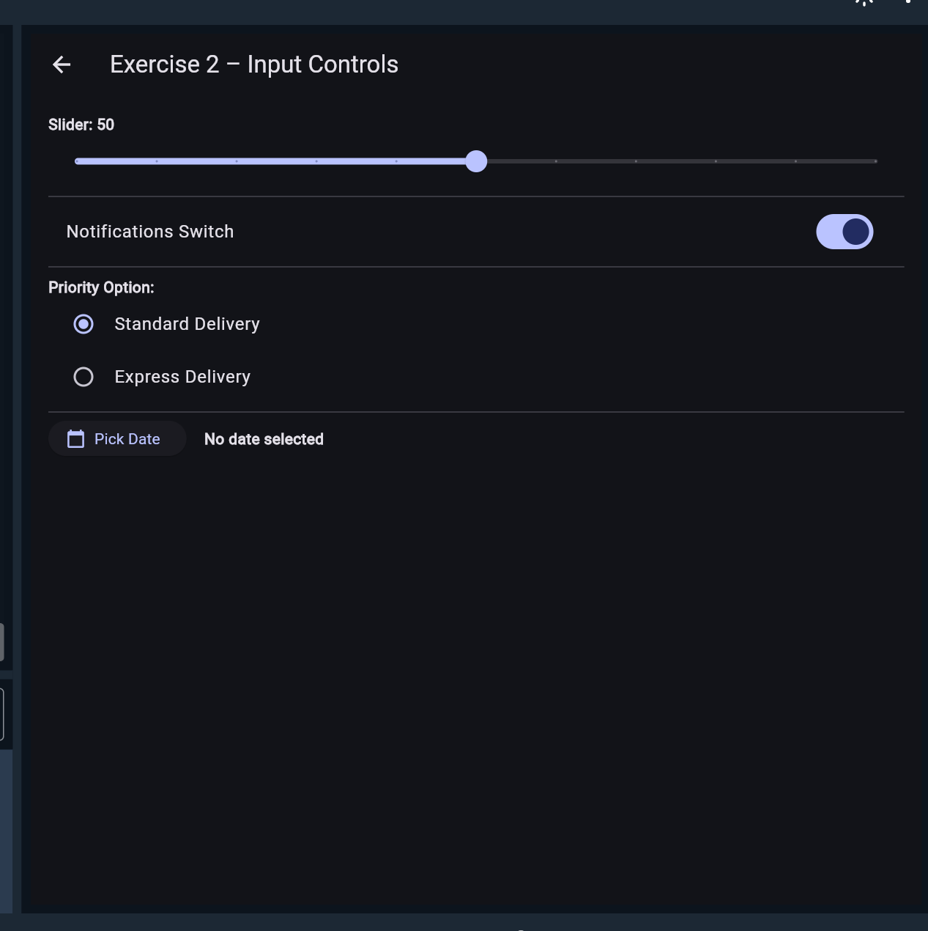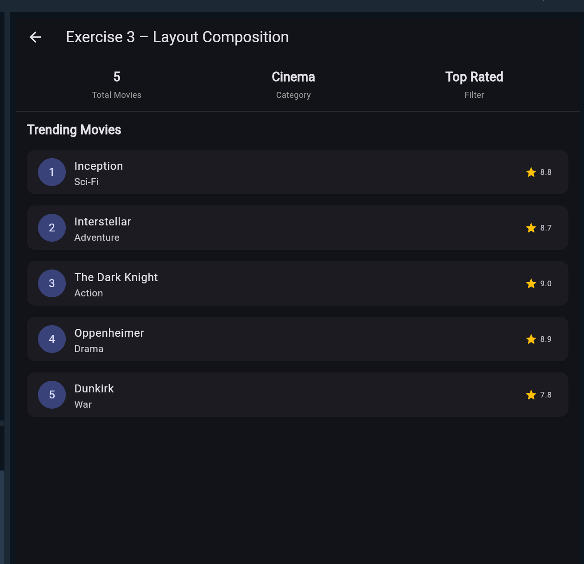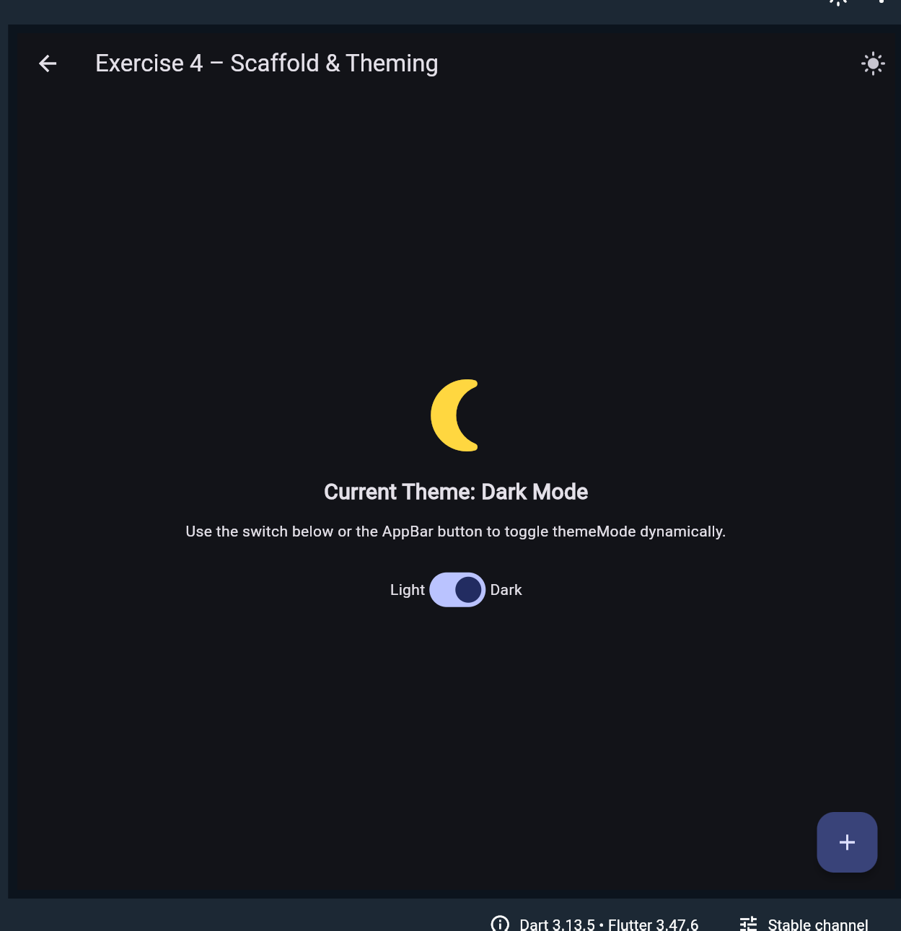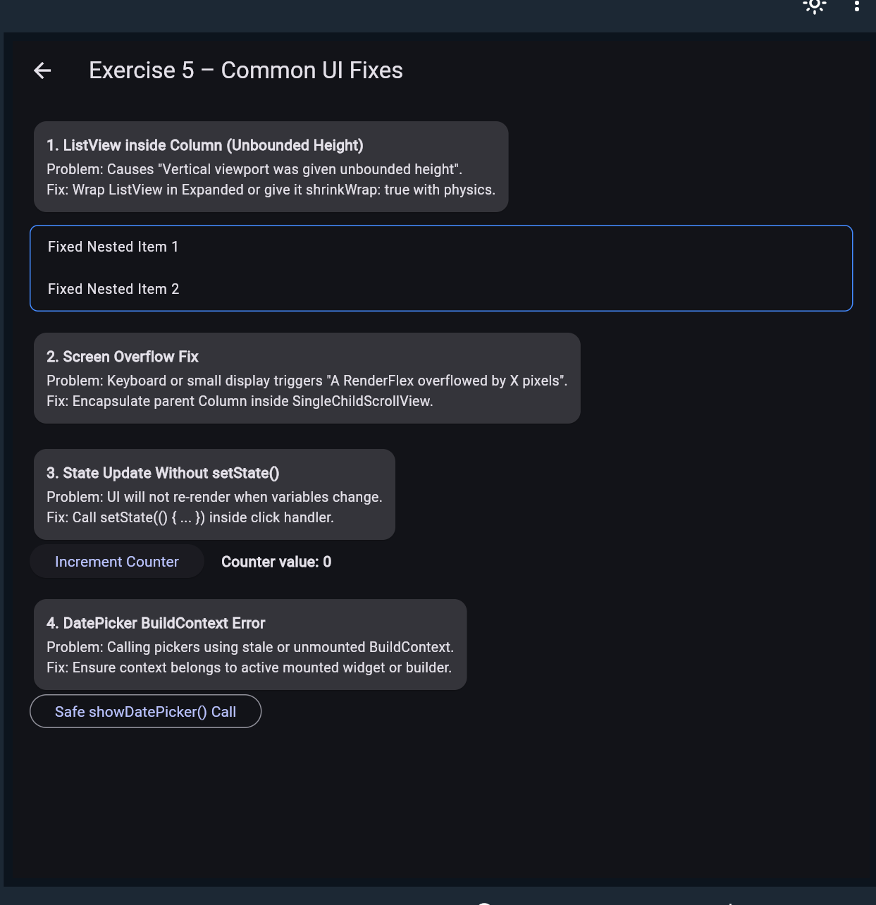
import 'package:flutter/material.dart';

void main() {
runApp(const Lab4App());
}

class Lab4App extends StatefulWidget {
const Lab4App({super.key});

@override
State<Lab4App> createState() => _Lab4AppState();
}

class _Lab4AppState extends State<Lab4App> {
// Theme state for Exercise 4 demonstration
ThemeMode _themeMode = ThemeMode.light;

void _toggleTheme(bool isDark) {
setState(() {
_themeMode = isDark ? ThemeMode.dark : ThemeMode.light;
});
}

@override
Widget build(BuildContext context) {
return MaterialApp(
title: 'Lab 4 – Flutter UI Fundamentals',
debugShowCheckedModeBanner: false,
themeMode: _themeMode,
theme: ThemeData(
useMaterial3: true,
colorSchemeSeed: Colors.indigo,
brightness: Brightness.light,
),
darkTheme: ThemeData(
useMaterial3: true,
colorSchemeSeed: Colors.indigo,
brightness: Brightness.dark,
),
home: HomeScreen(
isDark: _themeMode == ThemeMode.dark,
onToggleTheme: _toggleTheme,
),
);
}
}

// ============================================================================
// MAIN NAVIGATION MENU
// ============================================================================
class HomeScreen extends StatelessWidget {
final bool isDark;
final ValueChanged<bool> onToggleTheme;

const HomeScreen({
super.key,
required this.isDark,
required this.onToggleTheme,
});

@override
Widget build(BuildContext context) {
final menuItems = [
{
'title': 'Exercise 1 – Core Widgets Demo',
'page': const CoreWidgetsDemo(),
},
{
'title': 'Exercise 2 – Input Controls Demo',
'page': const InputControlsDemo(),
},
{
'title': 'Exercise 3 – Layout Demo',
'page': const LayoutDemo(),
},
{
'title': 'Exercise 4 – App Structure & Theme',
'page': AppStructureDemo(
isDark: isDark,
onToggleTheme: onToggleTheme,
),
},
{
'title': 'Exercise 5 – Common UI Fixes',
'page': const CommonUiFixesDemo(),
},
];

return Scaffold(
appBar: AppBar(
title: const Text('Lab 4 – Flutter UI Fundamentals'),
),
body: ListView.separated(
padding: const EdgeInsets.all(16),
itemCount: menuItems.length,
separatorBuilder: (_, __) => const SizedBox(height: 12),
itemBuilder: (context, index) {
final item = menuItems[index];
return Card(
elevation: 1.5,
shape: RoundedRectangleBorder(
borderRadius: BorderRadius.circular(12),
),
child: ListTile(
title: Text(
item['title'] as String,
style: const TextStyle(fontWeight: FontWeight.w600),
),
trailing: const Icon(Icons.chevron_right),
onTap: () {
Navigator.push(
context,
MaterialPageRoute(builder: (_) => item['page'] as Widget),
);
},
),
);
},
),
);
}
}

// ============================================================================
// EXERCISE 1: Core Widgets (Text, Image, Icon, Card, ListTile)
// ============================================================================
class CoreWidgetsDemo extends StatelessWidget {
const CoreWidgetsDemo({super.key});

@override
Widget build(BuildContext context) {
return Scaffold(
appBar: AppBar(title: const Text('Exercise 1 – Core Widgets')),
body: SingleChildScrollView(
padding: const EdgeInsets.all(16.0),
child: Column(
crossAxisAlignment: CrossAxisAlignment.center,
children: [
// 1. Headline Text
const Text(
'Explore Flutter Core Widgets',
style: TextStyle(fontSize: 22, fontWeight: FontWeight.bold),
textAlign: TextAlign.center,
),
const SizedBox(height: 16),

// 2. Material Icon
const Icon(
Icons.flutter_dash,
size: 64,
color: Colors.blueAccent,
),
const SizedBox(height: 16),

// 3. Image.network
ClipRRect(
borderRadius: BorderRadius.circular(12),
child: Image.network(
'https://picsum.photos/400/200',
height: 180,
width: double.infinity,
fit: BoxFit.cover,
errorBuilder: (context, error, stackTrace) => Container(
height: 180,
color: Colors.grey[300],
alignment: Alignment.center,
child: const Text('Image Preview Placeholder'),
),
),
),
const SizedBox(height: 20),

// 4. Card containing a ListTile
Card(
elevation: 3,
shape: RoundedRectangleBorder(
borderRadius: BorderRadius.circular(12),
),
child: const ListTile(
leading: Icon(Icons.star, color: Colors.amber),
title: Text('Featured Card Component'),
subtitle: Text('Clean card layout combining Icon and ListTile.'),
trailing: Icon(Icons.arrow_forward_ios, size: 16),
),
),
],
),
),
);
}
}

// ============================================================================
// EXERCISE 2: Input Widgets (Slider, Switch, RadioListTile, DatePicker)
// ============================================================================
class InputControlsDemo extends StatefulWidget {
const InputControlsDemo({super.key});

@override
State<InputControlsDemo> createState() => _InputControlsDemoState();
}

class _InputControlsDemoState extends State<InputControlsDemo> {
double _sliderValue = 50.0;
bool _switchValue = true;
String _selectedOption = 'Standard';
DateTime? _selectedDate;

Future<void> _pickDate() async {
final picked = await showDatePicker(
context: context,
initialDate: _selectedDate ?? DateTime.now(),
firstDate: DateTime(2020),
lastDate: DateTime(2030),
);
if (picked != null) {
setState(() {
_selectedDate = picked;
});
}
}

@override
Widget build(BuildContext context) {
return Scaffold(
appBar: AppBar(title: const Text('Exercise 2 – Input Controls')),
body: SingleChildScrollView(
padding: const EdgeInsets.all(16.0),
child: Column(
crossAxisAlignment: CrossAxisAlignment.start,
children: [
// Slider Control
Text('Slider: ${_sliderValue.toInt()}',
style: const TextStyle(fontWeight: FontWeight.bold)),
Slider(
value: _sliderValue,
min: 0,
max: 100,
divisions: 10,
label: _sliderValue.round().toString(),
onChanged: (val) => setState(() => _sliderValue = val),
),
const Divider(),

// Switch Control
SwitchListTile(
title: const Text('Notifications Switch'),
value: _switchValue,
onChanged: (val) => setState(() => _switchValue = val),
),
const Divider(),

// Radio Options (using ListTile + Radio to avoid deprecations)
const Text('Priority Option:',
style: TextStyle(fontWeight: FontWeight.bold)),
ListTile(
title: const Text('Standard Delivery'),
leading: Radio<String>(
value: 'Standard',
groupValue: _selectedOption,
onChanged: (val) => setState(() => _selectedOption = val!),
),
onTap: () => setState(() => _selectedOption = 'Standard'),
),
ListTile(
title: const Text('Express Delivery'),
leading: Radio<String>(
value: 'Express',
groupValue: _selectedOption,
onChanged: (val) => setState(() => _selectedOption = val!),
),
onTap: () => setState(() => _selectedOption = 'Express'),
),
const Divider(),

// DatePicker Action
Row(
children: [
ElevatedButton.icon(
onPressed: _pickDate,
icon: const Icon(Icons.calendar_today),
label: const Text('Pick Date'),
),
const SizedBox(width: 16),
Text(
_selectedDate == null
? 'No date selected'
: '${_selectedDate!.year}-${_selectedDate!.month.toString().padLeft(2, '0')}-${_selectedDate!.day.toString().padLeft(2, '0')}',
style: const TextStyle(fontWeight: FontWeight.w600),
),
],
),
],
),
),
);
}
}

// ============================================================================
// EXERCISE 3: Layout Composition (Column, Row, Padding, ListView)
// ============================================================================
class LayoutDemo extends StatelessWidget {
const LayoutDemo({super.key});

final List<Map<String, String>> movies = const [
{'title': 'Inception', 'genre': 'Sci-Fi', 'rating': '8.8'},
{'title': 'Interstellar', 'genre': 'Adventure', 'rating': '8.7'},
{'title': 'The Dark Knight', 'genre': 'Action', 'rating': '9.0'},
{'title': 'Oppenheimer', 'genre': 'Drama', 'rating': '8.9'},
{'title': 'Dunkirk', 'genre': 'War', 'rating': '7.8'},
];

@override
Widget build(BuildContext context) {
return Scaffold(
appBar: AppBar(title: const Text('Exercise 3 – Layout Composition')),
body: Column(
crossAxisAlignment: CrossAxisAlignment.start,
children: [
// Section 1: Row with stats
Padding(
padding: const EdgeInsets.all(16.0),
child: Row(
mainAxisAlignment: MainAxisAlignment.spaceAround,
children: [
_buildStat('Total Movies', '${movies.length}'),
_buildStat('Category', 'Cinema'),
_buildStat('Filter', 'Top Rated'),
],
),
),
const Divider(height: 1),

// Section 2: Header
const Padding(
padding: EdgeInsets.symmetric(horizontal: 16.0, vertical: 12.0),
child: Text(
'Trending Movies',
style: TextStyle(fontSize: 18, fontWeight: FontWeight.bold),
),
),

// Section 3: ListView.builder inside Expanded
Expanded(
child: ListView.builder(
padding: const EdgeInsets.symmetric(horizontal: 12.0),
itemCount: movies.length,
itemBuilder: (context, index) {
final movie = movies[index];
return Padding(
padding: const EdgeInsets.only(bottom: 8.0),
child: Card(
child: ListTile(
leading: CircleAvatar(
child: Text('${index + 1}'),
),
title: Text(movie['title']!),
subtitle: Text(movie['genre']!),
trailing: Row(
mainAxisSize: MainAxisSize.min,
children: [
const Icon(Icons.star, color: Colors.amber, size: 18),
const SizedBox(width: 4),
Text(movie['rating']!),
],
),
),
),
);
},
),
),
],
),
);
}

Widget _buildStat(String label, String value) {
return Column(
children: [
Text(value, style: const TextStyle(fontSize: 18, fontWeight: FontWeight.bold)),
const SizedBox(height: 4),
Text(label, style: const TextStyle(fontSize: 12, color: Colors.grey)),
],
);
}
}

// ============================================================================
// EXERCISE 4: Scaffold, AppBar, FAB & Dark Theme Toggle
// ============================================================================
class AppStructureDemo extends StatelessWidget {
final bool isDark;
final ValueChanged<bool> onToggleTheme;

const AppStructureDemo({
super.key,
required this.isDark,
required this.onToggleTheme,
});

@override
Widget build(BuildContext context) {
return Scaffold(
appBar: AppBar(
title: const Text('Exercise 4 – Scaffold & Theming'),
actions: [
IconButton(
icon: Icon(isDark ? Icons.light_mode : Icons.dark_mode),
tooltip: 'Toggle Theme',
onPressed: () => onToggleTheme(!isDark),
),
],
),
body: Center(
child: Padding(
padding: const EdgeInsets.all(24.0),
child: Column(
mainAxisAlignment: MainAxisAlignment.center,
children: [
Icon(
isDark ? Icons.nightlight_round : Icons.wb_sunny,
size: 80,
color: isDark ? Colors.amberAccent : Colors.orange,
),
const SizedBox(height: 16),
Text(
'Current Theme: ${isDark ? "Dark Mode" : "Light Mode"}',
style: const TextStyle(fontSize: 20, fontWeight: FontWeight.bold),
),
const SizedBox(height: 12),
const Text(
'Use the switch below or the AppBar button to toggle themeMode dynamically.',
textAlign: TextAlign.center,
),
const SizedBox(height: 24),
Row(
mainAxisAlignment: MainAxisAlignment.center,
children: [
const Text('Light'),
Switch(
value: isDark,
onChanged: onToggleTheme,
),
const Text('Dark'),
],
),
],
),
),
),
floatingActionButton: FloatingActionButton(
onPressed: () {
ScaffoldMessenger.of(context).showSnackBar(
const SnackBar(content: Text('FAB pressed! Screen scaffold working.')),
);
},
child: const Icon(Icons.add),
),
);
}
}

// ============================================================================
// EXERCISE 5: Debug & Fix Common UI Errors
// ============================================================================
class CommonUiFixesDemo extends StatefulWidget {
const CommonUiFixesDemo({super.key});

@override
State<CommonUiFixesDemo> createState() => _CommonUiFixesDemoState();
}

class _CommonUiFixesDemoState extends State<CommonUiFixesDemo> {
int _counter = 0;

@override
Widget build(BuildContext context) {
// FIX 2: Wrapped body with SingleChildScrollView to prevent overflow on small viewports
return Scaffold(
appBar: AppBar(title: const Text('Exercise 5 – Common UI Fixes')),
body: SingleChildScrollView(
padding: const EdgeInsets.all(16.0),
child: Column(
crossAxisAlignment: CrossAxisAlignment.start,
children: [
_buildFixCard(
'1. ListView inside Column (Unbounded Height)',
'Problem: Causes "Vertical viewport was given unbounded height".\n'
'Fix: Wrap ListView in Expanded or give it shrinkWrap: true with physics.',
),
const SizedBox(height: 8),

// Demo of ListView with shrinkWrap inside Column
Container(
decoration: BoxDecoration(
border: Border.all(color: Colors.blueAccent),
borderRadius: BorderRadius.circular(8),
),
child: ListView.builder(
shrinkWrap: true, // Fix applied
physics: const NeverScrollableScrollPhysics(), // Fix applied
itemCount: 2,
itemBuilder: (context, i) => ListTile(
dense: true,
title: Text('Fixed Nested Item ${i + 1}'),
),
),
),
const SizedBox(height: 16),

_buildFixCard(
'2. Screen Overflow Fix',
'Problem: Keyboard or small display triggers "A RenderFlex overflowed by X pixels".\n'
'Fix: Encapsulate parent Column inside SingleChildScrollView.',
),
const SizedBox(height: 16),

_buildFixCard(
'3. State Update Without setState()',
'Problem: UI will not re-render when variables change.\n'
'Fix: Call setState(() { ... }) inside click handler.',
),
Row(
children: [
ElevatedButton(
onPressed: () {
// FIX 3: setState() triggers build() re-run
setState(() {
_counter++;
});
},
child: const Text('Increment Counter'),
),
const SizedBox(width: 16),
Text('Counter value: $_counter',
style: const TextStyle(fontWeight: FontWeight.bold)),
],
),
const SizedBox(height: 16),

_buildFixCard(
'4. DatePicker BuildContext Error',
'Problem: Calling pickers using stale or unmounted BuildContext.\n'
'Fix: Ensure context belongs to active mounted widget or builder.',
),
Builder(
builder: (validContext) => OutlinedButton(
onPressed: () {
showDatePicker(
context: validContext,
initialDate: DateTime.now(),
firstDate: DateTime(2020),
lastDate: DateTime(2030),
);
},
child: const Text('Safe showDatePicker() Call'),
),
),
],
),
),
);
}

Widget _buildFixCard(String title, String explanation) {
return Card(
color: Theme.of(context).colorScheme.surfaceContainerHighest,
child: Padding(
padding: const EdgeInsets.all(12.0),
child: Column(
crossAxisAlignment: CrossAxisAlignment.start,
children: [
Text(title,
style: const TextStyle(fontWeight: FontWeight.bold, fontSize: 14)),
const SizedBox(height: 4),
Text(explanation, style: const TextStyle(fontSize: 13)),
],
),
),
);
}
}

